Brute force extraction until a non-archive file is file ( flag.txt)

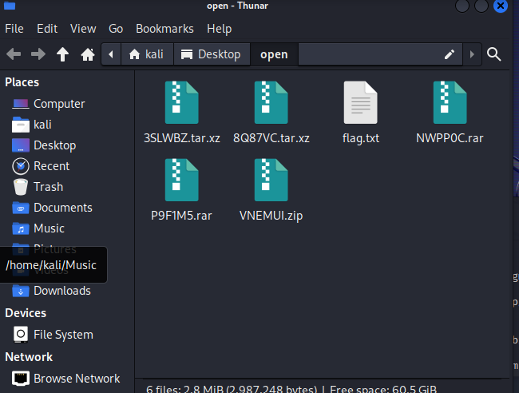

String = Q1o0MDY3e0lfMTB2RV9SM2NVcnMxdjNfejFwfQ==

Encoded in Base64

A python script was used to extract each compressed file. Each compressed file is extracted into the base directory and the folder that is generated along with it is deleted. This is to prevent an extremely long path directory This is because there is a maximum limit to the number of characters that can be used in a file path. In Windows, for example, the maximum path length is 260 characters, while in some Linux distributions, the maximum path length is 4096 bytes. In this case, I used Kali and initially I did encounter this limit, thus the script was changed to counter this.